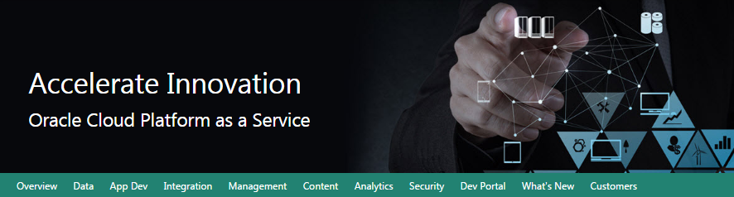

Oracle Data Management Cloud Workshop

Database Cloud Service

Updated: XXX 0, 0000



**Safe Harbor Statement**

The following is intended to outline our general product direction. It is intended for information purposes only, and may not be incorporated into any contract. It is not a commitment to deliver any material, code, or functionality, and should not be relied upon in making purchasing decisions.

The development, release, and timing of any features or functionality described for Oracle’s products remains at the sole discretion of Oracle.

**Oracle Training Materials – Usage Agreement**

Use of this Site (“Site”) or Materials constitutes agreement with the following terms and conditions:

1. Oracle Corporation (“Oracle”) is pleased to allow its business partner (“Partner”) to download and copy the information, documents, and the online training courses (collectively, “Materials") found on this Site. The use of the Materials is restricted to the non-commercial, internal training of the Partner’s employees only. The Materials may not be used for training, promotion, or sales to customers or other partners or third parties.

2. All the Materials are trademarks of Oracle and are proprietary information of Oracle. Partner or other third party at no time has any right to resell, redistribute or create derivative works from the Materials.

3. Oracle disclaims any warranties or representations as to the accuracy or completeness of any Materials.  Materials are provided "as is" without warranty of any kind, either express or implied, including without limitation warranties of merchantability, fitness for a particular purpose, and non-infringement.

4. Under no circumstances shall Oracle or the Oracle Authorized Delivery Partner be liable for any loss, damage, liability or expense incurred or suffered which is claimed to have resulted from use of this Site of Materials. As a condition of use of the Materials, Partner agrees to indemnify Oracle from and against any and all actions, claims, losses, damages, liabilities and expenses (including reasonable attorneys' fees) arising out of Partner’s use of the Materials.

5. Reference materials including but not limited to those identified in the Boot Camp manifest cannot be redistributed in any format without Oracle written consent.

Contents

Section 1: Database Cloud Service Overview 4

1.1: Introduction 4

1.2: Objectives 4

1.3: Lab Requirements 4

1.4: Retrieve Public IP for Client Image 5

1.5: Create Database Cloud Service Instance 13

1.6: Configuration and Image Exploration 25

Section 2: Cloud Migration 41

2.1: Introduction 41

2.2: Objectives 41

2.3: System Requirements 41

2.4: Cloud Migration Using Pluggable Databases 41

2.5: Cloud Migration Using Data Pump 65

2.6: Cloud Migration Using SQL Developer Carts 79

Section 3: Backup and Recovery 88

3.1: Introduction 88

3.2: Objectives 88

3.3: Lab Requirements 88

3.4: Oracle Public Cloud Backup Recovery 88

Section 4: Database Development 101

4.1: Introduction 101

4.2: Objectives 101

4.3: Lab Requirements 101

4.4: Alpha Office and APEX 101

# Database Cloud Service Overview

### Introduction

This lab will help give you a basic understanding of the Oracle Database Cloud Service and it’s capabilities around administration and database development.

We will walk through creating a new Database Cloud Service instance. After the database has been created, you will connect into the Database image using an SSH private key and familiarize yourself with the image layout. Next you will learn about SSH tunneling using an SSH configuration file. This file will be used to tunnel multiple ports to a remote OPC instance. Using the tunnels, you will learn how to access various Database consoles.

### Objectives

* Create Database Cloud Service
* Configure security with SSH
* Explore VM and cloud consoles

### Lab Requirements

* VNC Viewer to connect to an Image running on Oracle’s IaaS Compute Service.
* Laptop capable of connecting to the internet and running VNC Viewer
* Cloud environment access details provided by instructor in advance of the class

**Note:** *Use the table below and fill in the blanks as you go through the labs. Create a text file or note on your VNC desktop to keep track of important information you’ll need throughout the lab exercises so that you can easily copy and paste the information.*

|  |  |
| --- | --- |
| Cloud Data Center: |  |
| Identity Domain: |  |
| Login Username (s): |  |
| Login Password: |  |
| Alpha01A-DBCS Cloud Public IP Address: |  |
| Alpha01A-DBCS Cloud Private IP Address: |  |
| Site Location ID: |  |
| Alpha01B-DBCS Cloud Public IP Address: |  |
| Alpha01B-DBCS Cloud Private IP Address: |  |
| Client Public IP Address: |  |
| Client Private IP Address: |  |
| VNC Viewer Port #: |  |
| Client Image VNC Viewer Password: |  |

### Retrieve Public IP for Client Image

For the Database Cloud Service Workshop we will be using a Client Image running in the Oracle Compute cloud to simulate the on premise environment. This client image is running Linux and contains a preinstalled Oracle 12.1.0.2 database with a pluggable database that we will migrate to the Oracle Public Cloud Database instance. The client image contains SQL Developer 4.1, SQL*Plus and other utilities that will be used to connect and manipulate both the local and cloud database instances.

The Client Image is a VM that is running on Oracle’s IaaS Compute service.

#### Retrieve Public IP for Client Image

* Login to your Oracle Cloud account
* Open a browser and go to the following URL: https://cloud.oracle.com
* Click Sign In in the upper right hand corner of the browser

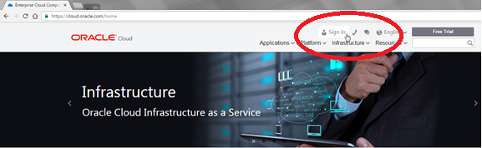

* Under My Services > Select Data Center … select the region from the drop down list. Your instructor will provide this information to you prior the course. 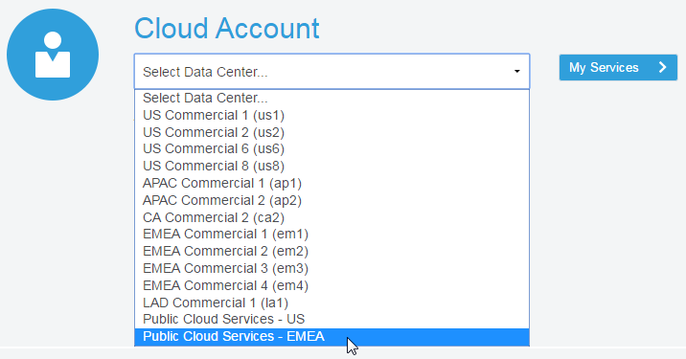
* Enter the identity domain and click Go

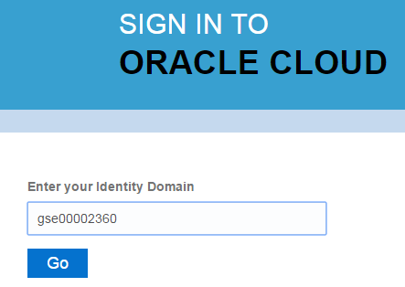

* After entering the Identity Domain you will enter the User Name and Password
* Click Sign In

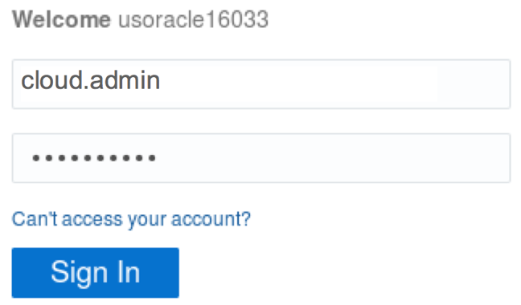

**NOTE**: The Identity Domain, User Name and Password values were provided to you by your instructor prior to starting this lab.

* You should see the Dashboard summarizing all of your available services. Compute, backup, and storage are all related to the Database Cloud Service.

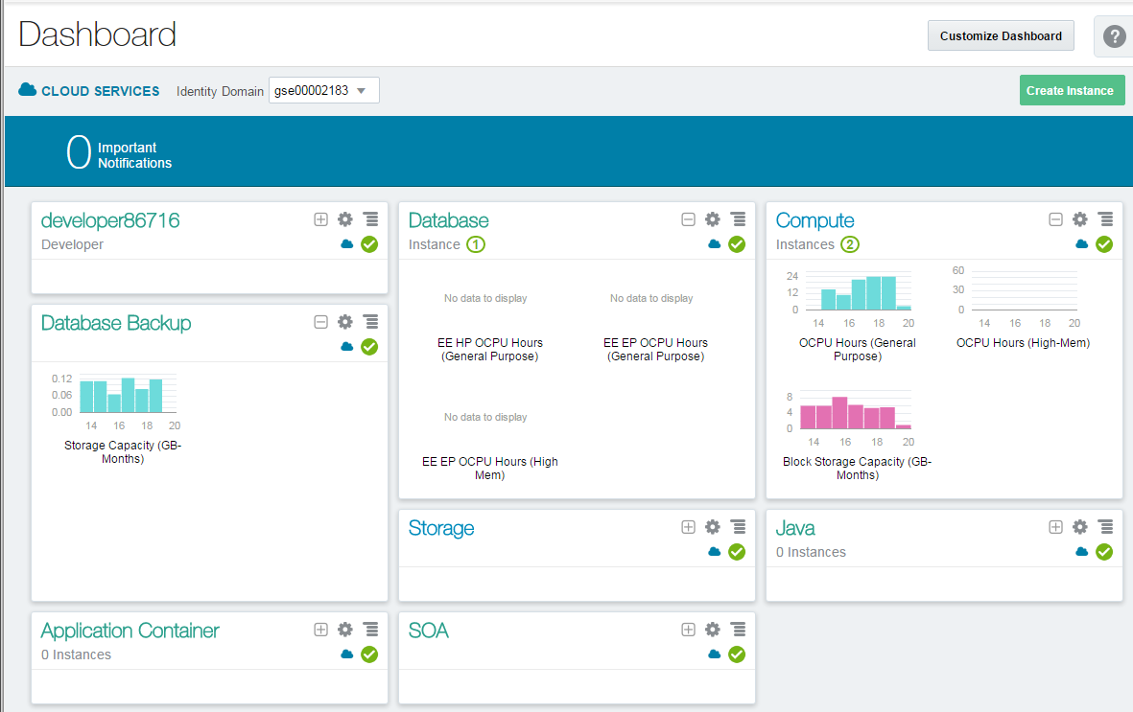

* If there’s a service that’s not visible, click on the Customize Dashboard dropdown and add each service as a favorite by clicking on theShow button next to the service.

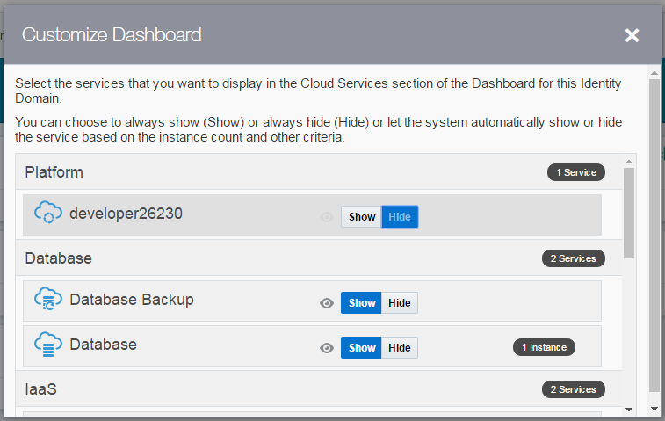

* From the main dashboard, click on the Compute service link to access the Compute Service Console. This is where we will get the IP address of our database service.

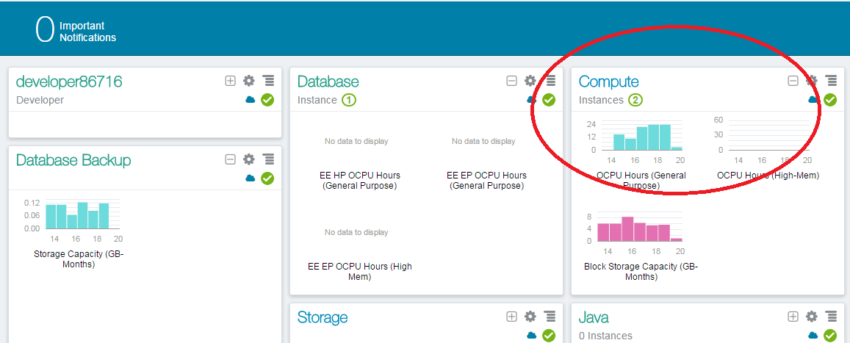

* From this page you can view general information about this Compute Cloud Service. Click on the Open Service Console button.

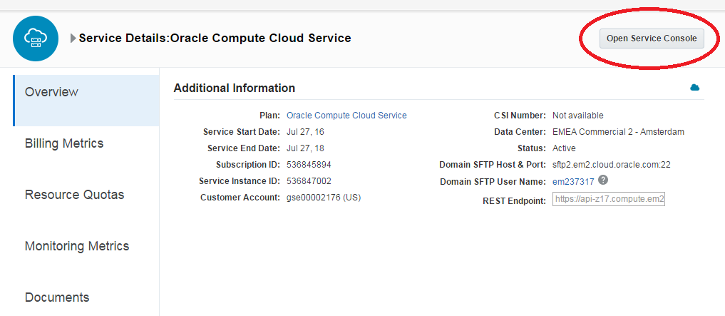

* The Compute Service Console will give you a summary of the resources your cloud service is using and a list all running VM’s.

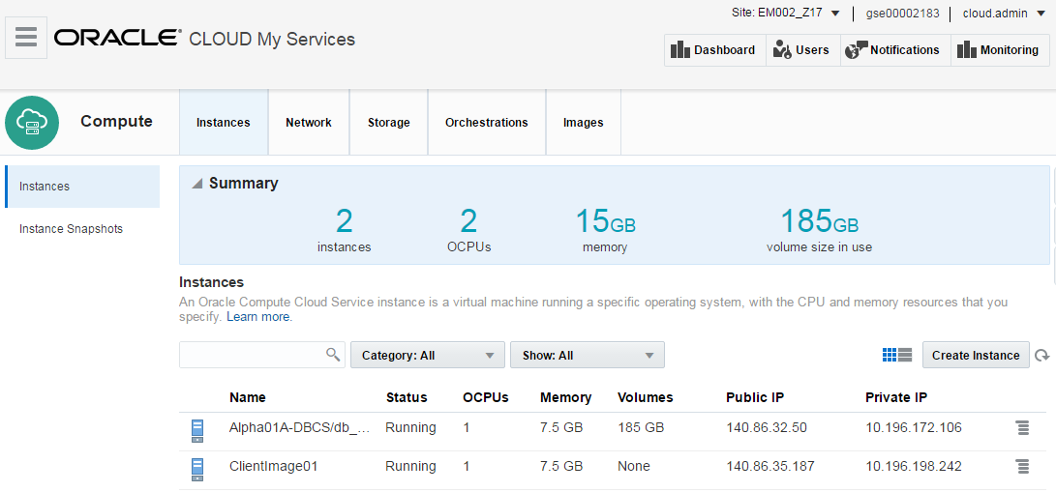

* Identity Domains have multiple sites. If you don’t see your VM images in the Compute Console, you may be in the wrong site.

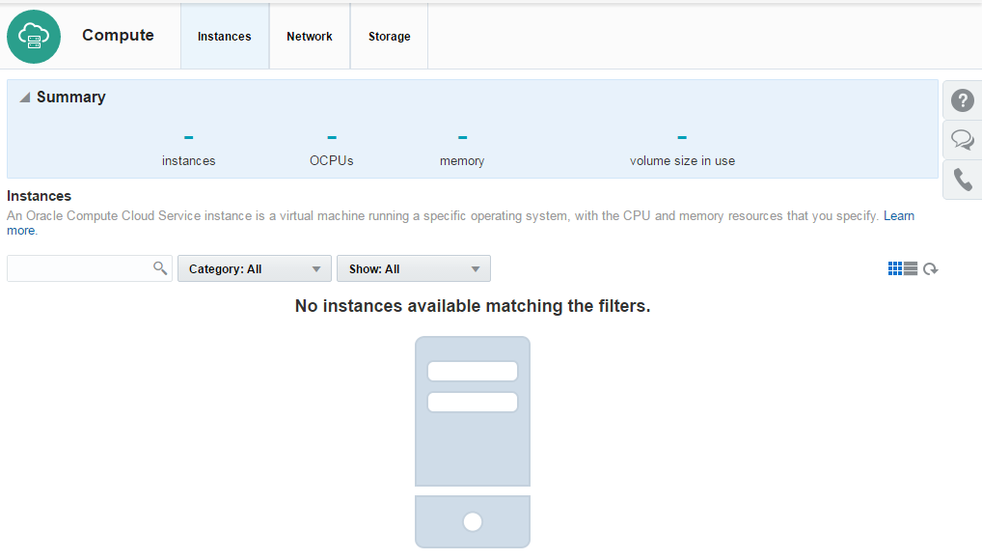

* Please ask your instructor which site the Client Image is running on. If necessary, click the Site dropdown at the top of the page to access the Site Selector and choose the correct site.

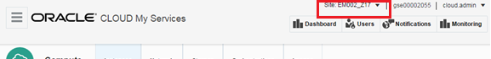

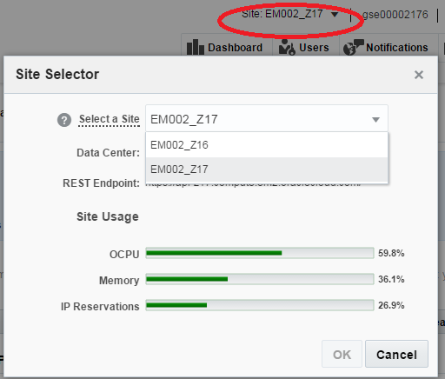

* Once the correct site has been selected, locate the instance named ClientImage01 and copy the Public IP.
* Note: Keep this IP Address somewhere accessible, like a notepad or text document. We will use this IP with VNC to connect to the cloud client desktop.

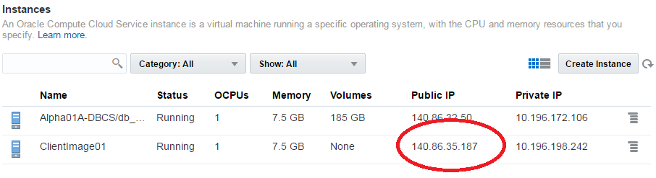

#### Connect to Client Image using VNC Viewer

* From your desktop run the VNC Viewer application and enter the Public IP address you just obtained, with a display port separated from the IP address by a colon <:443> and click Connect

***Note 1:*** *If connecting inside an Oracle office through the ‘clear-guest’ network, and the VNC session won’t connect or times out, try port :10.*

**Note 2:** If you do not already have a VNC Viewer installed on your computer you will need to download it. Or ask the instructor for the Real VNC Viewer executable.

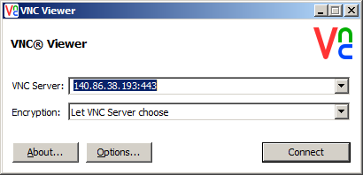

* Click Continue on the encryption message.

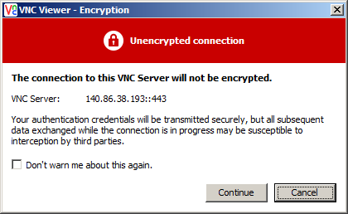

* Enter the password supplied by your instructor and click OK

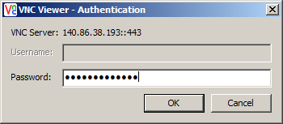

* Verify that you can see and interact with the Linux desktop. You are now connected to the Client Image that will be used for all labs.

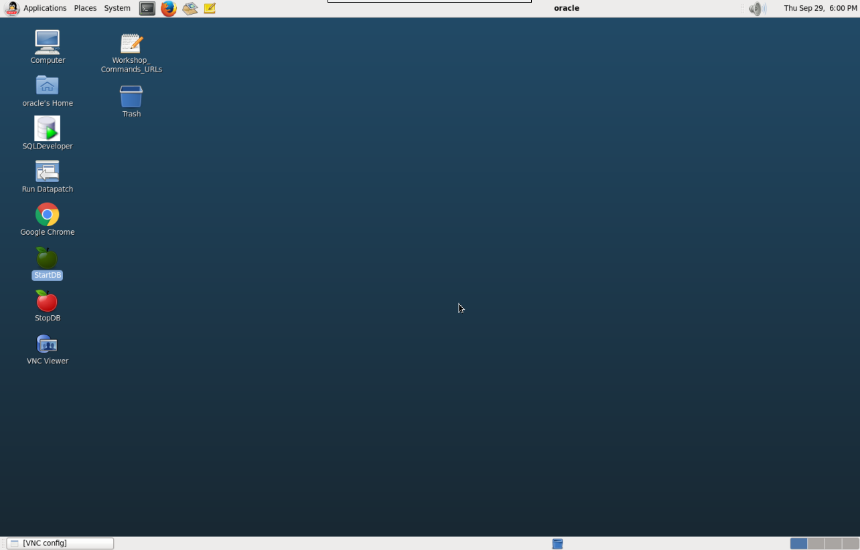

### Create Database Cloud Service Instance

#### Login to your Oracle Cloud account

* From within the VNC Session open the **Google** Chrome browser Image result for chrome browser icon and go to the following URL: [**https://cloud.oracle.com**](https://cloud.oracle.com)
* Click Sign In in the upper right hand corner of the browser
* Under the Cloud Account field click on the Select Data Center drop down, choose the data center location (for demos and trials, it’s usually EMEA) then click on the My Services > button.

**IMPORTANT** - Under My Services, the **Data Center location** is provided to you in the lab connection instructions.



* In the next screen enter the identity domain and click GO



* Enter the cloud User Name and Password and click Sign In



**NOTE**: The Identity Domain, User Name and Password values are provided in the lab connection instructions.

* You should see the Dashboard summarizing all of the available services.

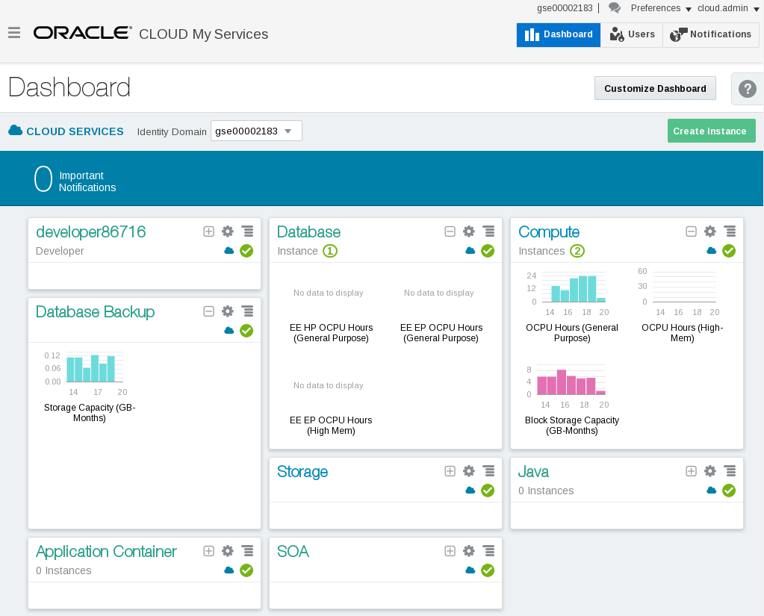

#### Create Database Cloud Service

* From the main dashboard, click on the Database service link

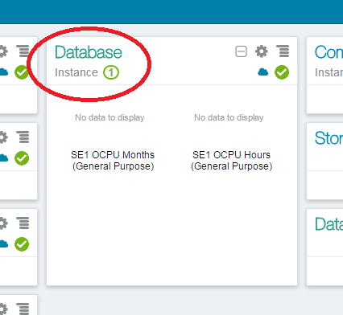

* From this page you can view general information about this Database Cloud Service. Click on the Open Service Console button. ---**Stop here**

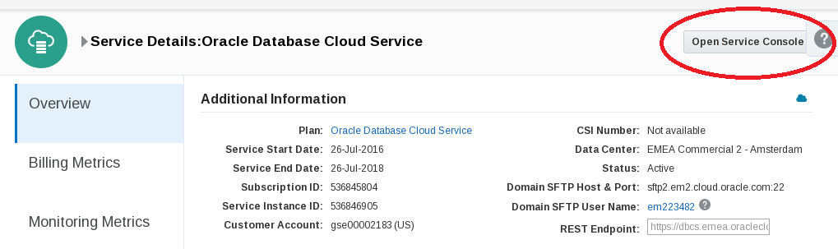

* From the console, click the Create Service button
* ***Note:*** *There should already be a service provisioned (Alpha01A-DBCS). It was created earlier in order to save lab time. This service will be utilized later in the lab, don’t interact with it at this point.*

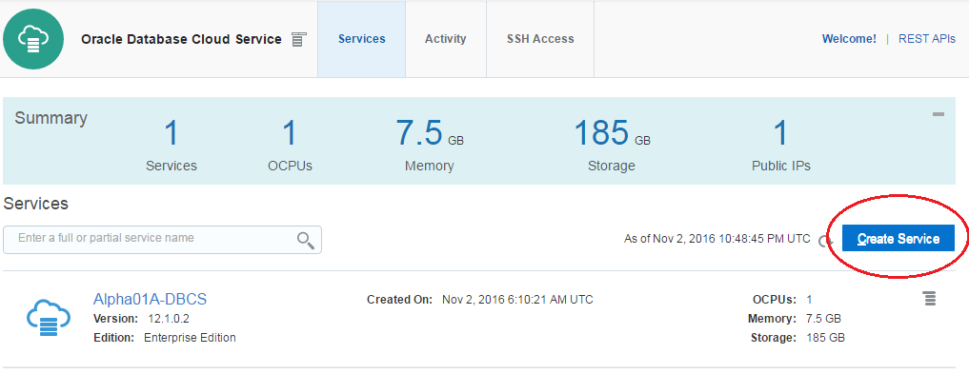

 Important Step! In the next steps, you will provide identity service configuration details and select the compute shape for your new Database instance.

**Note:** Service Name must be unique. When providing a name, please note you may have another service instance already created in your account.

* Use the information from the following table for the Service Configuration details:

|  |  |
| --- | --- |
| **Basic Service Information** | |
| **Service Name** | Alpha01B-DBCS |
| **Description** | Alpha Office Database Cloud Service |
| **Service Level** | Oracle Database Cloud Service |
| **Metering Frequency** | Hourly |
| **Software Release** | Oracle Database 12c Release 1 |
| **Software Edition** | Enterprise Edition |
| **Database Type** | Single Instance |

*Below are examples of the alternate selections for each*

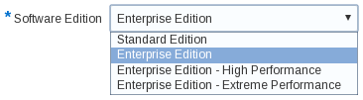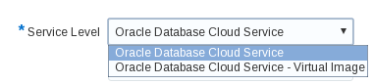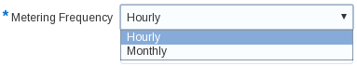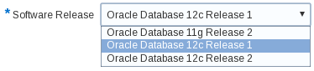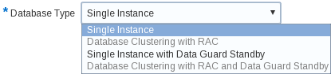

* Your screen should look like this …

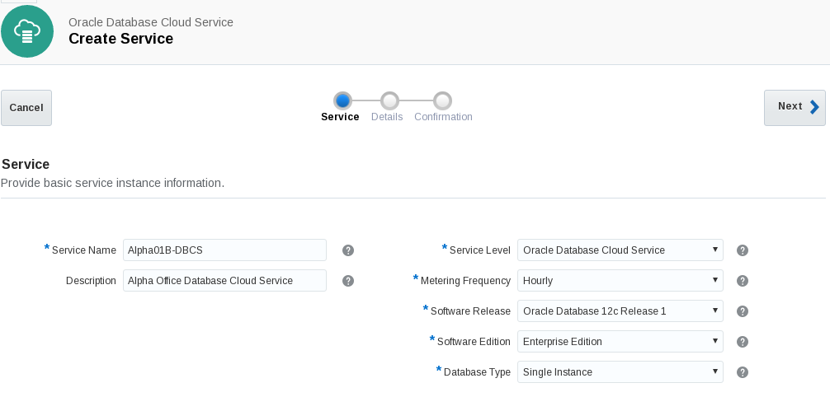

* Click **Next** to continue
* In the next screen we will fill out the **Service Details** for our Database Cloud instance. The screen will be broken down into sections to make the information easier to understand.
* Here is an example of the completed Service Details Screen. Continue to the next step for details on how to fill this form in correctly.

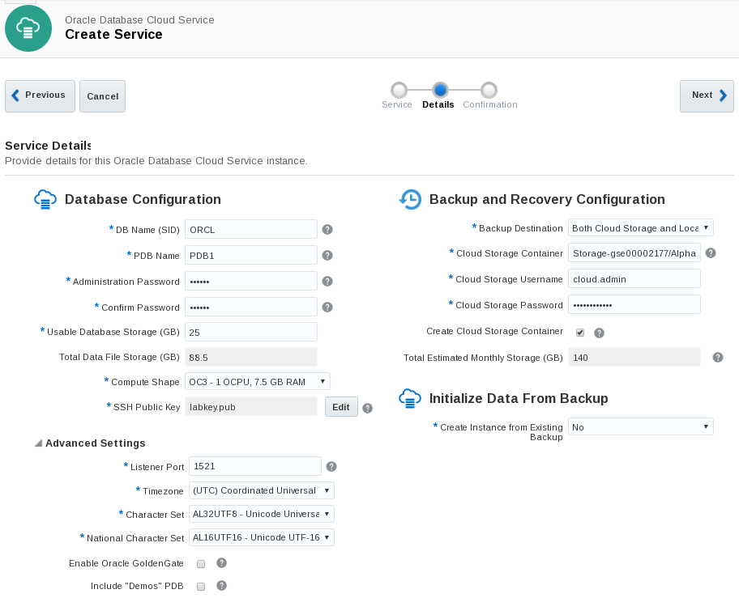

Section 1: Database Configuration:

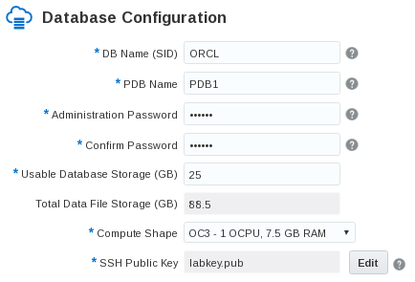

|  |  |
| --- | --- |
| **Section 1: Database Configuration** | |
| **DB Name (SID)** | ORCL |
| **PDB Name** | PDB1 |
| **Administration Password** | Alpha2014_ |
| **Usable Database Storage (GB)** | 25 |
| **Total Data File Storage (GB)** | 88.5 |
| **Compute Shape** | OC3 – 1 OCPU, 7.5 GB RAM |
| **SSH Public Key** | labkey.pub |

Note: The SSH Key has already been created for you. It’s named labkey.pub and can be found on the client image under /u01/OPCWorkshop/lab/

* On the SSH Public Key section, click Edit



* Click on the Edit button to browse for the labkey.pub

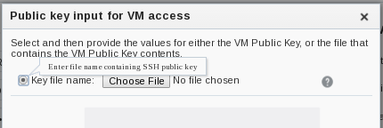

* Make sure the Key File name: radio button is checked and click Choose File
* Navigate to the following subdirectory on your system: /u01/OPCWorkshop/lab/
* Choose the file named labkey.pub